Terms of Reference
  - Coordinated Access and Assessment (CAA)
Youth Placement Committee (YPC)

Background
Throughout 2012 and 2013 the Calgary Homeless Foundation (CHF) engaged in a thorough community consultation plan regarding Coordinated Access and Assessment (CAA); the community was vocal about participating in the placement of participants (individuals experiencing homelessness who access homeless serving agencies) in their housing programs. In order to respect agency autonomy over participant program placements, the concept of Placement Committees was developed. The committees would allow for dialogue, discussion and placements to be made in a group rather than one agency making the decisions in silo.

Much of the policy, process and practices are outlined in the CAA Manual. These Terms of Reference help define the purpose, process, and structure of this committee.

Purpose
The CHF has a defined System of Care with a spectrum of funded services available for individuals experiencing homelessness. The goal is to develop an integrated system of care with CAA at the centre.
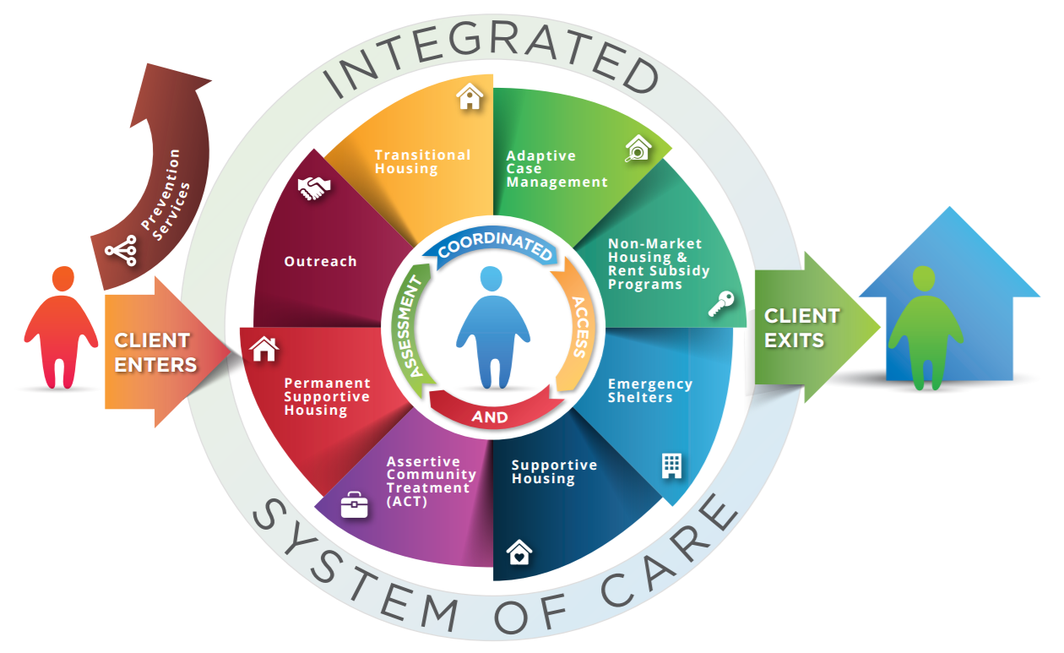
The primary purpose of this Youth Placement Committee (YPC) is to match Youth as defined within the ToR, into the most appropriate housing and/or services available through the agencies represented at the Committee. This is done through a triage process as agencies discuss participants’ needs as found on the CAA (TAY) VI-SPDAT Spreadsheet.

Term

Defining Youth Served at CAA
For the purposes of this Terms of Reference (ToR) and the committee, Youth are defined as individuals up to the age of 25 who are experiencing homelessness.

Prioritization
In order to best match participants to the most appropriate services and available housing, CHF utilizes the VI-SPDAT (also known as the NSQ, or Needs and Services Questionnaire). For Youth, the TAY-VI-SPDAT will be used.
There are five distinct streams of housing supports accessed through the YPC – Group-based, Rapid Re-housing (RRH), Place-based Bridge Housing (PBBH), Scattered Site Supportive Housing and Place-based Supportive Housing (PBSH). For the purposes of this Terms of Reference and the committee, outlined below will be the different triage criteria for each of the housing supports offered through YPC. There is interplay with chronicity and the prioritization for each of these program streams. For example, for SSSH or PBSH, we seek to identify those who have higher chronicity; for programs such as RRH or Bridge Housing we look at moderate or low chronicity, generally. Self-identified chronicity (months) may play into our overall view of total chronicity as we use the data and assessment tools available to us to support meaningful decision-making.

 | Rapid Re-housing
TAY-VI-SPDAT | Scores 10 and under
Tri-morbidity | Needing support in one or two life domains
Chronicity | Brief – newer to homelessness. Based on HMIS data on entries to CAA system, length of time on CAA & self-reported data
Age | 18+, 24

 | Scattered-site Supportive Housing
TAY-VI-SPDAT | Scores 11 and above*
Tri-morbidity | Yes - Based on the NSQ*
Chronicity | High - Based on HMIS data on entries to CAA system, length of time on CAA & self-reported data

 | PBSH
TAY-VI-SPDAT | Scores 11 and above
Tri-morbidity | Yes, Based on NSQ
Chronicity | High - Based on HMIS data on entries to CAA system, length of time on CAA & self-reported data. LOS on CAA >100 days
Age | 18+, 24

 | PBBH
TAY-VI-SPDAT | Scores 11 and below
Bi-morbidity | Yes, Based on NSQ
Chronicity | Moderate to low chronicity. Based on HMIS data on entries to CAA system, length of time on CAA & self-reported data
Age | 18+, 24

Additionally, the YPC will look at prioritizing youth exiting systems such as addictions treatment centres, the justice and health systems, as well as youth (<18) shelters. These youth must also meet other criteria relative to the type of housing that would be most supportive of their needs. YPC also prioritizes youth aging out of the youth sector (24-year old youth).
Youth who are pregnant will also be prioritized as needed.
Participants with completed NSQs are maintained in CHF’s Homeless Management Information System (HMIS) system and a list of these individuals within this scoring range will be brought to the YPC for triaging and placement purposes. Agencies will then pick up participants based on the triage methodologies contained within this ToR.

Exceptions
While the primary focus of this committee will be within this scoring range, a variety of factors can be considered upon participant placement which can exceed this range.
For example, programs that attend YPC and can operate outside of these triage parameters include Non-Market Housing programs such as Calgary Housing Company and CUPS Graduated Rent Subsidy. These programs have their own Terms of Reference (TOR) that better define their participant requirements and intake processes (please refer to Post Case Management Programs Terms of Reference).
In addition, niche programs, such as rapid rehousing, which are designed to serve less complex or those with lower chronicity will look at a lower VI score range and lower chronicity.

Committee Membership
Membership of the YPC will be drawn from the staff of a wide range of homeless serving partner agencies that focus on “Youth” participants (as defined above). The intent of the membership is for agencies to have representation to support the acquisition of participants into their program or to provide support to other agencies for this matter.
The Placement Committee will ask their management to attend if there are issues needing to be resolved that cannot be addressed with the current membership.

YPC System Partners & Guests
Guests are welcome to attend Placement Committee so long as they understand the purpose and goals of the committee and are respectful of the process. The committee can decide to prohibit guests from attending if the common goals are not respected, understood or followed. If a member would like to invite a guest, please notify the Chair or Co-Chair by email prior to the meeting. The guest will be introduced and the goals of the committee will be reviewed with the guest. They will be asked to sign a confidentiality form.
Note: If an agency would like to inquire about membership, please email Calgary Homeless Foundation at: CAA@calgaryhomeless.com

Membership Roles & Responsibilities
Membership is agency based and not necessarily program based. To fulfill the goals of the YPC representation must be appropriate; the regular attendee should be able to speak to multiple programs under one agency, or in the case that an agency has several programs at YPC one person from each program could attend under one agency.
Regular attendance isn’t tied to an individual’s position or title, what is important is the individual’s knowledge to speak to persons who may be discussed for placement, and how to screen/pick up appropriate referrals and transfers on the list for the program. It is also expected that regular attendees are familiar with the different types of programs that exist throughout each sector, there is a CHF Resource Guide to assist with this.

Expectation of Participation
The placement process is a collaborative one and committee members are expected to attend meetings regardless of whether or not their program has spaces available. If an agency is unable to attend a meeting, they can request referrals via email in their absence and for transparency, update the committee on the next meeting of the results of the participant referral. Regular attendees for an agency/program are expected to be present at each meeting limiting side conversations, stay for the entire meeting, and engage in conversation outside their placement that require the committee to work together on a solution. A contact list will be shared by CHF to all regular attendees.

Role | Responsibilities
YPC Chair | The Chairperson is responsible for making sure that each meeting is planned effectively, conducted according to the Terms of Reference and that matters are dealt with in an orderly, efficient manner.  In addition, the chair will follow these general guidelines:  - Operate/manage the excel document for members to follow during the meeting (CHF can offer support as requested).  - Ensure the structure of the meeting is followed and time is respected.  - Guide the group through difficult decisions; if consensus cannot be achieved items will tabled for the next meeting or specific plans will be implemented to find resolution on contentious issues (i.e. agency leadership consulted, working groups established, time set aside at next meeting to tackle the issue).  - Keep the committee light, celebrating successes, and participant-centred with a strength-based lens for both participants and programs.  - Ensure the Terms of Reference are up to date and reflect the purpose and vision of the group.
YPC Co-Chair | The Co-Chair is responsible for completing all the participant notes during the meeting. It is important the notes make sense to people that are not in attendance at the meetings. The notes must be clear, concise and relevant. All referrals and exits will be documented and entered into HMIS.  In accordance with the Data Quality Plan the Co-Chair will ensure; completeness, timeliness, accuracy and consistency of placement notes and data collection related to the placement process.
General Membership | Members will:  - Accept referrals as per the triage model.  - Provide insight on participant/program fit, respectfully challenging the table when required and appropriate.  - Respect agency and program autonomy.  - All case management activities within the housing programs are not in the scope of this committee.  - The Placement Committee will provide feedback on policies, process and operations to be included in the updates of the CAA Manual.
Calgary Homeless Foundation | The CHF will send a member from the System Planning Team to observe placement committee meetings and fill the role of Chair and Co-Chair.  In addition to Chair and Co-Chair, their role at the meetings is to document program gaps, identify needs of the committee and identify questions around agency capacity. The CHF will use the information data and for informed decision making, advocacy work and future planning.  In addition, the CHF will backbone the committee by providing administrative support, HMIS support, community communications, and coordination efforts of the CAA program.

Goals of the Committee
- The Placement Committee will help ensure housing programs within the System of Care maintain a minimum of 95% occupancy as per CHF KPIs.
- All members of the Placement Committee will follow the process for program placement (as stated in this Terms of Reference) ensuring timely and efficient service delivery as defined in the Standard Operating Procedures.
- All members of the Placement Committee will participate in good faith, with respect, integrity and ethically towards the common goal of ending homelessness with a participant centered approach.
- The Placement Committee will document learnings from each meeting and ensure the Standard Operating Procedures reflects these learnings.
- The Placement Committee will work towards collecting and disseminating data regarding participants who do not fit into the System of Care. This information should be shared with partners from other systems and outside our system of care (health, justice, treatment centres) in the form of briefing notes provided by CHF.
- Placement Committee operates under the principle that sharing of participant information is necessary to ensure effective provision of services, continuity of care and efficient use of resources.

Meetings
The YPC will meet:
Date: | every Wednesday
Time: | 9:30AM to 10:30AM
Location: | Virtual

Note: Communication for meetings will be via email. If a new staff would like to be added to the email distribution list, please email Calgary Homeless Foundation at: CAA@calgaryhomeless.com

Meeting Agenda
Agenda Item
- Introductions (if required)
- Agency updates
- Updates on program placements:
  - “Leave on one week”
  - “Exit success”
  - “Return to Triage List”
  - “MIA”
  - “Needs Contact Info”
  - “Needs Update”
- Celebrating Success – this is the time during the meeting program will report which participants have been housed!
- Transfers – when participants require a different program an NSQ should be competed and entered into HMIS CAA along with ensuring the transfer questions are answered. A new program placement can be examined during this time of the meeting.
- NSQ are reviewed and through collaboration and available program spaces matches will be made by the group.
- Other agenda items as required
- Committee meeting end
Note: In the case that there are no participant spaces in the system of care,; the committee can elect to have the option to meet and use this time to discuss housing options outside CHF funded programs or other discussions as necessary. The committee will meet to make recommendations to CHF on funding based on gap analysis.

Triaging & Program Matching
In ideal conditions, the focus of the committee will be to refer the participants in most imminent need of housing and supports to programs with open spaces in the system of care that are best suited to meet their needs. The Committee will try not to refer participants whose needs exceed the program’s services. For example, the Committee will work to ensure participants requiring a placed-based model (harm reduction & guest management) are not referred to scattered-site programs.
While individuals meeting the aforementioned criteria should remain the focus on the CAA Triage spreadsheet, the additional categories that the committee will consider include the following: (not in order of importance, case-by-case assessment):
Category
Perceived Risk
System Exits
Pregnancy
Engagement – Check-in
Age
Shelter Days/History of Homelessness

Additional factors of Engagement and Vulnerability will be utilized to triage in like cases. Individuals that are highly engaged and checking-in with outreach staff or SORCe on a regular basis will be considered for placement above individuals who have no level of engagement (so long as other triage factors are the same as comparative individuals).
There are several examples of why individuals are not accepted in programs; individuals may refuse the program or programs may refuse the individuals. Regardless of the reason, HMIS notes must clearly articulate why the referral was not accepted.
The participant should be given the option to be placed back on the triage list. Participant choice for program placement or preference should always be respected; it should be considered but it does not mean they will get into the program due to triage factors and open spaces.
If a participant is no longer in need of a match, they will be removed from HMIS. If they re-connect, their NSQ should be updated in HMIS in order for their assessment to be reviewed at the next Placement Committee.
Individuals are deemed MIA if staff members have attempted contact more than three times This is done case by case; the participant is given a minimum of three weeks to make contact before they are deemed MIA. Once a participant makes contact, an HMIS note will be made and their CAA status will be changed and they will be put back on the triage list.

Placement Process
Once a participant is matched to an agency & program at YPC, the participant is then referred to the agency & program through HMIS.

Terminology
The agency is responsible for reporting on the outcome of the participant placement back to the YPC using the following standard language:

Transfers:
Each meeting will prioritize a 50/50 split between transfers and triage list, with transfers taking priority for odd number of spaces available.
This will be done by the available spots per program, NOT per program ‘type’
Transfer Principles:
- Informed consent, including knowledge about the housing and services available from the potential receiving programs, is a prerequisite of the transfer process.
- All potential transfers must be reviewed by CAA placement table, if deemed an appropriate transfer then the required supporting process and procedures to flag transfer in 'Program Transfers' in HMIS is completed.
- All transfers must be done through "Warm Transfer", this means that the program who is requesting the transfer will provide continued support to the participant until the new program has appropriately and fully accepted the participant into the program and is actively supported (up to 3 months as outlined in the Case Management Standards that can be accessed here).
- Expectation of a warm transfer is that there will be a meeting with both caseworkers and the program participant. A transition case plan will be created to reflect current goals and warm transfer. This will be aided by the Warm Transfer Summary.
Sector Transfers:
- The CAA encompasses the Adult, Youth, and Family sectors, which form the System of Care as a whole.
- If a participant is flagged for transfer to another CAA sector, the current CAA sector table will review the transfer and rationale will be required to determine what supports are available that the current sector cannot provide, prior to placing the participant on the requested CAA sector list. If deemed an appropriate transfer then the required supporting process and procedures to flag transfer in 'Program Transfers' in HMIS is completed.
- Once HMIS process is complete for sector transfer, a representative from the participant transfer agency may (recommended) present participant at the receiving sector placement table.
- If the receiving agency has sound rationale proving they are unable to support the participant in their program, the transferring program will work with the participant to find an alternate solution.
The Transfer Process

Unique Sector Supports
Each sector within the System of Care (Adults, Youth, and Family) is made up of a portfolio of agencies and programs that provide services and supports that are tailored to the unique needs of Adults, Youth, and Families. For a detailed overview of what supports and programs are available, please see the Resource Guides found under the Resources tab here: ( http://calgaryhomeless.com/agencies/coordinated-access-assessment/ ).
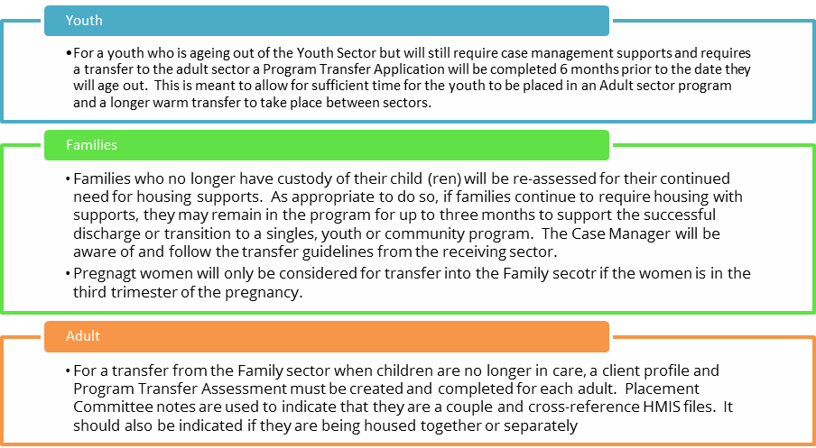
Warm Transfer Summary:
Once a transfer referral is made at any of the three placement tables it is expected that the referring agency complete the Warm Transfer Summary in HMIS to assist with a warm transfer to the intaking agency.

Grievances & Appeals
Grievances should be a standing item on the agenda, so we can work out particularly for practice details.
There are two types of grievances related to CAA. For simplicity’s sake, the participant has been directed to bring any grievances forward to the SORCe team. The SORCe team should direct the participant as appropriate to their type of grievance per the descriptions below:

Grievance Processes for Participants Presenting at SORCe
Type | Examples | Subcategory | Process to Follow
CAA General | - Participant thinks their confidentiality has been breached at placement.  - Participant wants to withdraw from CAA but is informed that their electronic record will continue to exist (locked).  - Participant is frustrated they have not been placed yet.  - Participant thinks a decision was made that did not comply with CAA Policies or Standard Operating Procedures.  - Participant feels that their assessment is not reflective of their situation. | - CAA Processes and Protocols at SORCe | - CAA staff at SORCe will follow Distress Centre protocols for addressing participant grievances.  - If participant still unsatisfied with grievance procedure, can pursue grievance with CHF per the grievance process for CHF participants with grievance against CHF funded agency that has not been resolved at the agency level.
 |  | - CAA Processes and Protocols at Another Agency | - CAA staff at SORCe will document the details of the grievance and work collaboratively with CHF to determine next steps.  - If necessary, CHF will engage the agency to enact their grievance process and correct gaps in process.
 |  | - CAA Placement or HMIS | - CAA staff will document the details of the grievance and work collaboratively with CHF to determine next steps.  - CAA staff will communicate the outcome to the participant.  - If participant still unsatisfied with grievance procedure, can pursue grievance with CHF per the grievance process for CHF participants with grievance against CHF funded agency that has not been resolved at the agency level.
Housing Strategist | - Participant feels they were not treated fairly by the Housing Strategist | - CAA Housing Strategist at SORCe | - CAA staff at SORCe will follow Distress Centre protocols for addressing participant grievances.  - If participant still unsatisfied with grievance procedure, can pursue grievance with CHF per the grievance process for CHF participants with grievance against CHF funded agency that has not been resolved at the agency level.
 |  | - CAA Housing Strategist at Another Agency | - CAA staff will document the details of the grievance and work collaboratively with CHF to determine next steps.  - CAA staff will communicate the outcome to the participant.  - If participant still unsatisfied with grievance procedure, can pursue grievance with CHF per the grievance process for CHF participants with grievance against CHF funded agency that has not been resolved at the agency level.

Governance & Reporting
The Committee seeks consensus on all placement decisions and Terms of Reference policies.
For difficult issues requiring meaningful dialogue and decisions, working groups will be formed. Members can volunteer to participate in working groups. The working group will report back to the committee on identified solutions and the committee will implement the decisions. Working groups must document their findings to be included in the Terms of Reference Appendices.
The Committee Reports to:
- Each representative on the Committee will report to their own agency’s leadership.

